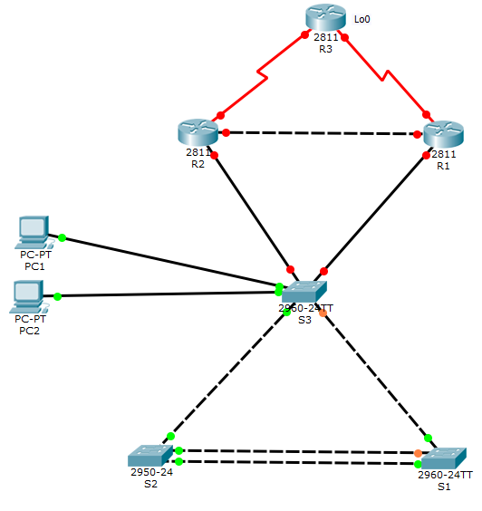

INTERNET

1. Create the basic configuration of devices:

* hostnames: R1, R2, R3, S1, S2, S3
* console and vty line password, and enable secret: cisco

2. S1-S2 connection should be 200Mbps

3. Use Rapid PVST on all switches. S1 should be the Root switch.

4. IP addressing:

* all switches and pc-s are in the 192.168.70.0/24 network, default gateway 192.168.70.1
* R1 and R2 serve redundant gateway for network, R1 is the primary gateway
* S1, S2, S3 IP addresses: 192.168.70.11, 192.168.70.12, 192.168.70.13
* PC1 and PC2 IP addresses: 192.168.70.21, 192.168.70.22
* R1-R2 link use the first usable subnet of 192.168.10.0/24 network
* Serial links use the 199.1.1.64/26 network.
  + R1-R3 link use the first smallest usable subnet of 199.1.1.64/26 network
  + R2-R3 link use the second smallest usable subnet of 199.1.1.64/26 network
* R3 Lo: 201.1.1.1/32

5. Configure EIGRP routing protocol with authentication, password is cisco

R3 loopback interface is the default GW to the Internet

**You have to able to telnet from PC-s to all switches, and routers.**